Fourth Consultation Event

Consultation with Children aged 5 to 11 years attending Cuckney School.
Tuesday 24th July 2014

Introduction
One of the key drivers for the steering group has been the concept of regeneration of the four villages, and part of this is the reversal of the increasing age demographics of the population. If this becomes a reality and we are able to increase the numbers of families and children, then the Neighbourhood should look to be a place were children are happy and well catered for. The Steering Group felt that children themselves should have a direct say into what is good or not good at present within our community, what should be retained and what they would like to see change.
With this aim, the Steering Group engaged Planning Consultant, Helen Metcalfe of Planning With People, to do a Half Day session with children at the village school in Cuckney.

Background
Historically Cuckney village school has been the school for the children of Welbeck Estate. In more recent years, with people prepared and able to travel, an increasing number of the children come from without the estate area. Exact figures are impossible to obtain but from local anecdotal evidence we know that 30 years ago the number of children attending the school was just over 50. Less than a handful came from without the estate area. Of around 50 children, about half came from the four villages that make up our Neighbourhood –i.e. 25 children - and the other half from the nearby estate village of Nether Langwith. Now there are over 110 children in the school but only 8 are from the Neighbourhood villages. Seven of these eight children took part in the consultation event, their ages ranging from 5 to 11.

Format

The programme for the consultation was as follows:

1.15 pm Who are we and what are we here for?

1.20 pm What is town planning and how does it affect your life?

1.30 pm Activity 1: Can you draw the view outside your bedroom window?

1.45 pm Feedback: what do you see and how have planners affected your life?

1.55 pm Activity 2: Let’s look at maps of Cuckney, Norton, Holbeck and Welbeck.
Can you find where you live? Your school? Where you play?

2.05 pm If you were town planners what would you do to improve where you live?
On the maps use red spots for what you ‘dislike’, and green spots for what you ‘like’. Add sticker notes to explain why.

2.20 pm Can you design your ideal village?
Think of all the things you like about your area, think about all the planning issues you have considered this afternoon. Using models can you create the ideal village? Work in groups.

2.30 pm Break

2.40 pm Design your ideal village

2.50 pm Review and award prize to winning group.

3.00 pm Close

Event

For the first 10 minutes Helen gave a short presentation about planning, and what we were going to do through the afternoon. The children then split into two groups.

Group 1 – The four children from Holbeck and Welbeck villages
Group 2 – The three children from Norton and Cuckney villages

Using their own drawings, the maps, and toy village pieces, the children were able to identify what they had now, what they liked and how they may like things to be. All likes and dislikes were justified by writing a comment against each red and green spot.

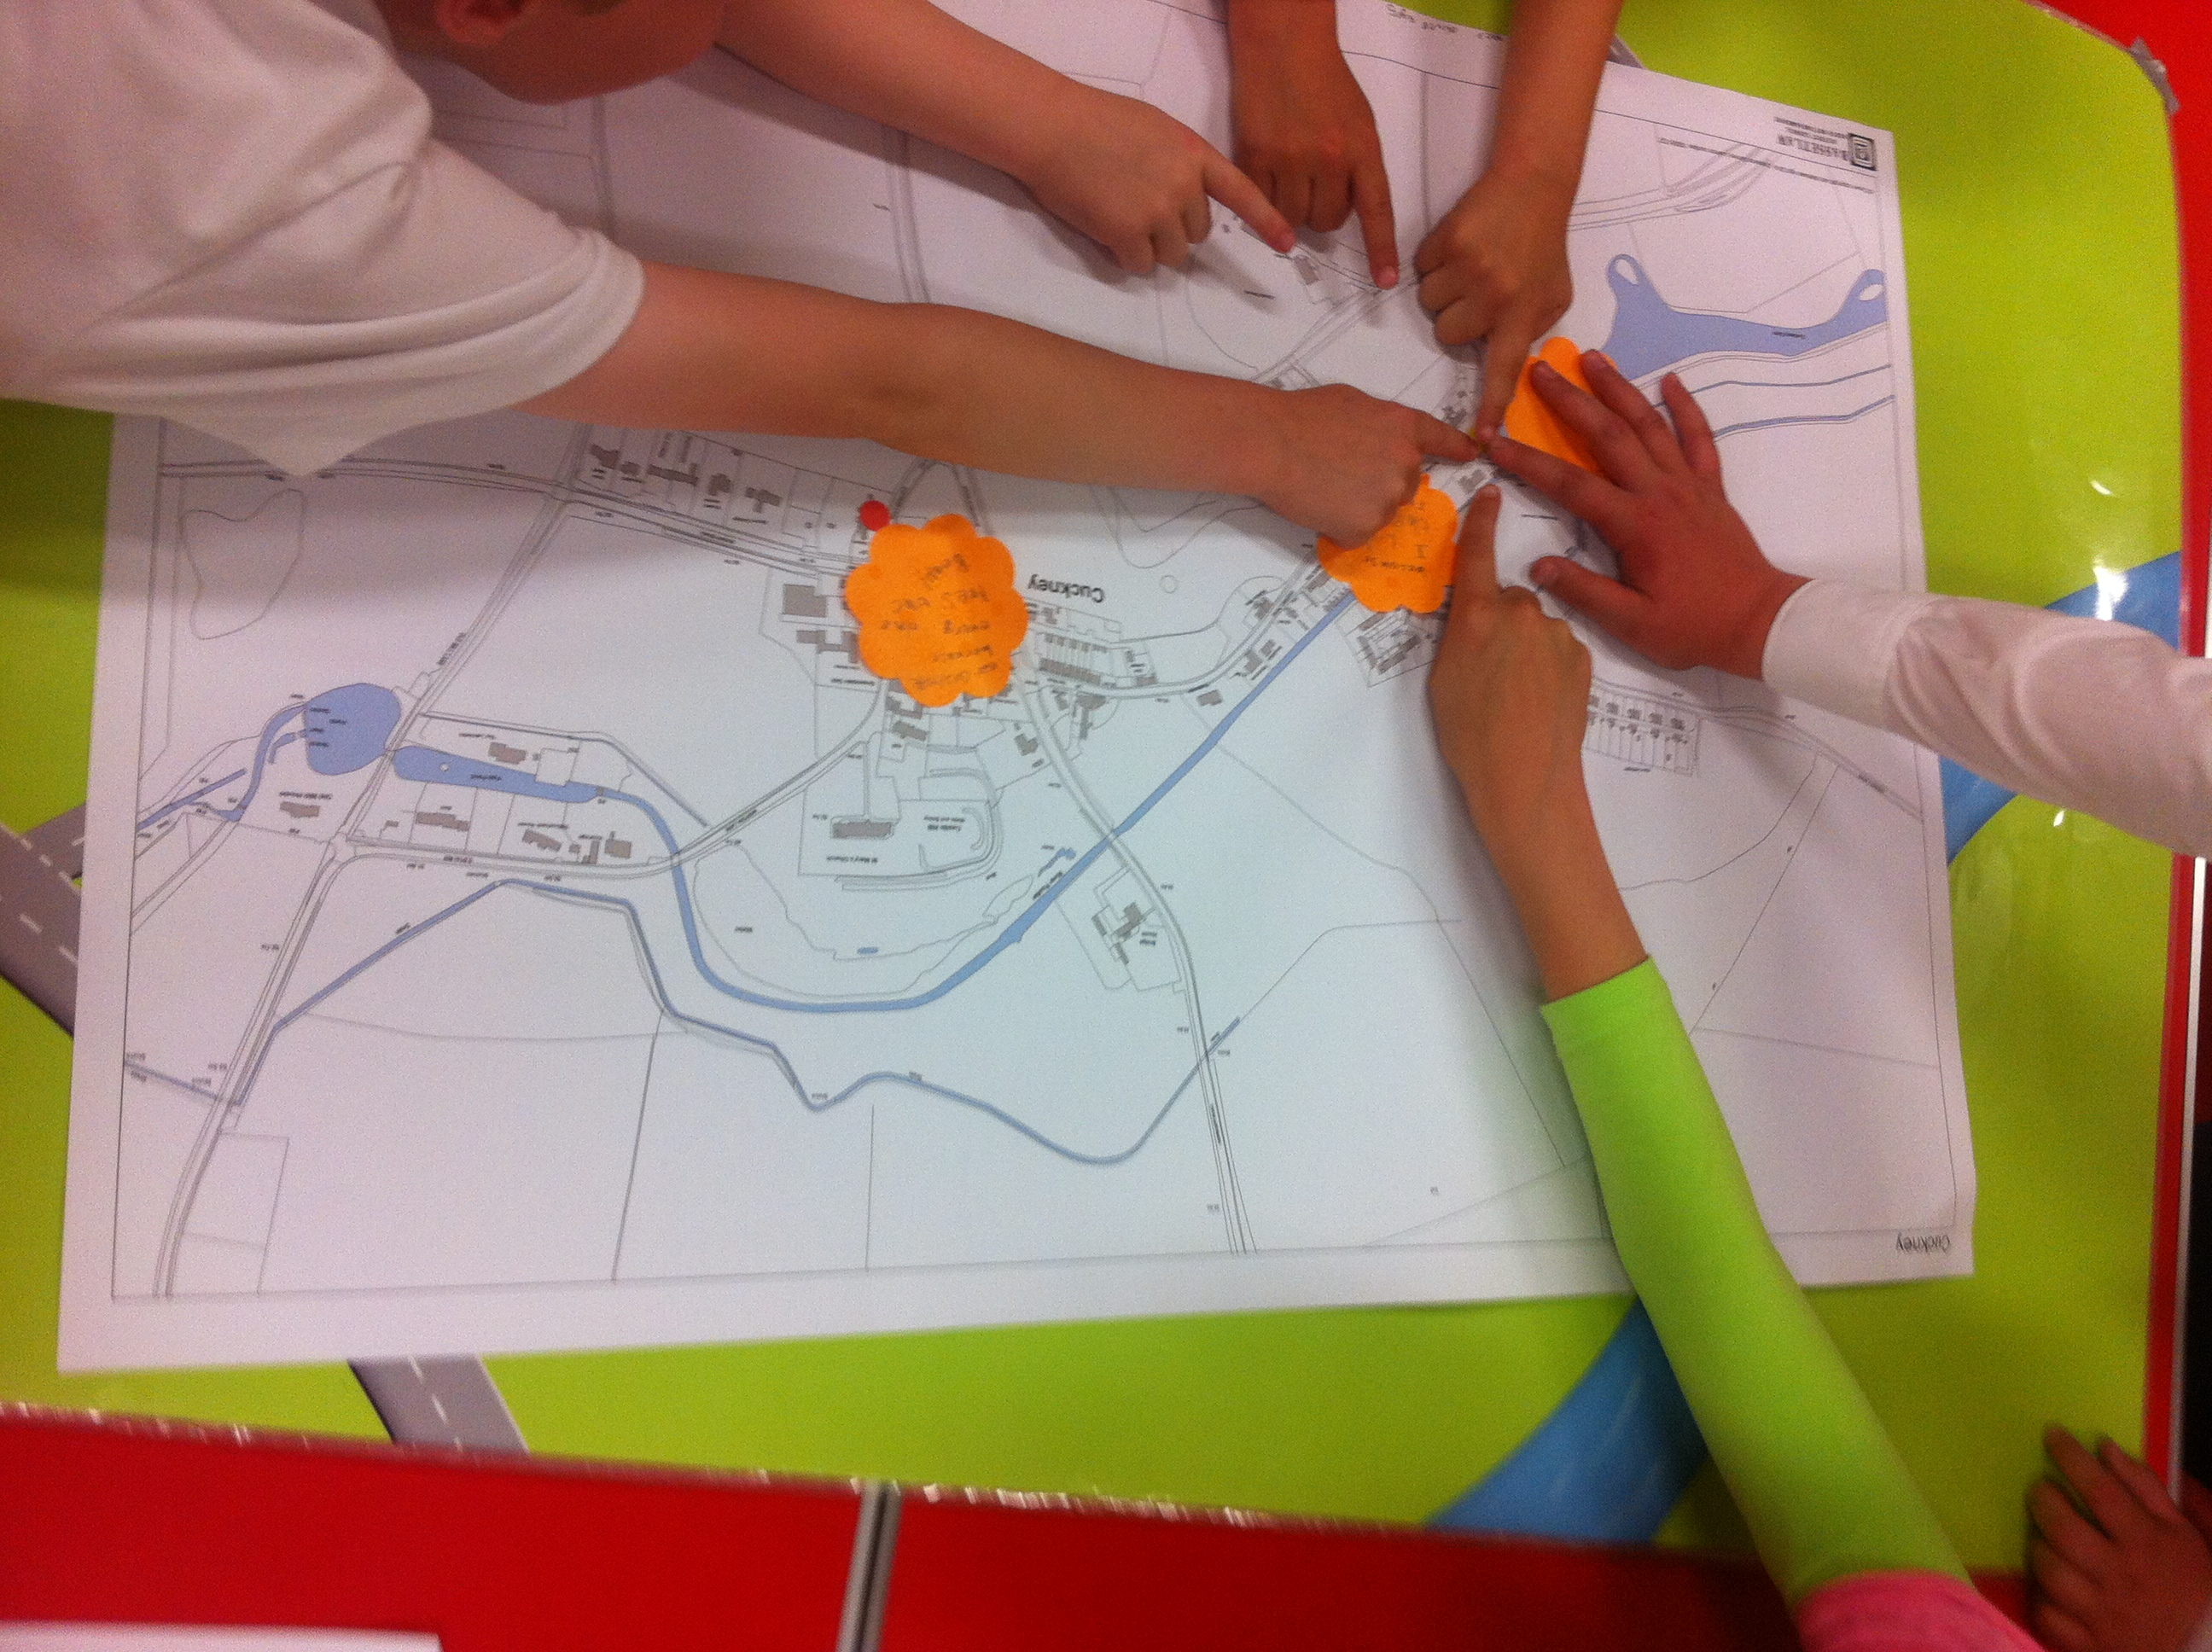

Outcome

The children, without exception appeared to enjoy the exercise. All participated, asked numerous questions, and volunteered many answers as Helen presented the maps and ideas. From the soft evidence of sitting, watching and listening to them through the afternoon, and the harder evidence of what they presented on the maps and the comments they wrote we can say:

- They are happy with, and value the environment in which they live and do not wish to see this lost. In particular the presence of green spaces, birds and animals was seen as important.
Some written comments emphasizing this were:
“There are Swans there”
“Because there are horses there”
“We like to go and feed the ducks and swans”
“We like to watch the chickens and ducks in the pub garden”
“We like to play round the trees”
“There is a wood near it too, so you can hear the birds calling”
“There is corn growing there and you can run through it”
“It is a good walk and a good view of the church and pond”
“There is a Conker tree and we collect them”

- Having play facilities in each village is liked though in the two smaller one’s the equipment was felt to be inadequate.
“I like the Swings and zip wire there that we can play on “
“I like the climbing frame”

- Street area’s away from busy roads are valued
“Feel safe walking on the pavements because you can go where there is not too much traffic”
“It’s a good road to cycle on”

Negative comments were few.
“ We have no red stickers because we like everything about the village”
“I have no red stickers because I like everything”
Red Sticker – “Because everyone here is always pressing the Beap” (This was referring to a narrow busy road junction)
“ The park could be better – better play stuff like spiders web climbing frame, zip wire, basket swing” (Referring to Holbeck Playpark).

Summary of Findings

The low number of children at the school starkly exemplifies one of the issues our Neighbourhood Plan is attempting to address; ie an ageing population unable to move into more suitable accommodation, due to lack of local availability, and so living in family housing, preventing people with school age children moving into the area.

Children do enjoy living in the area; they value it rural nature and the opportunities this gives for play and leisure activities.

The fact that three of the villages have a play area was also valued though children do like to have modern equipment. Improving these facilities may be an action point for the Plan.

In two of the villages they liked being able to go to the park safely as they were centrally placed and away from heavy traffic. We need to bear in mind that developments were children will play need to have a minimum of vehicular access.

