Cuckney, Norton, Holbeck & Welbeck Neighbourhood Development Plan
The Environmental Assessment of Plans and Programmes Regulations 2004
SEA Screening Statement
Introduction
The requirement for a Strategic Environmental Assessment to be undertaken on development plans and programmes that may have a significant environmental effect is outlined in European Union Directive 200142/EC. The Environmental Assessment of Plans and Programmes Regulations 2004 (the Regulations) state that this is determined by a screening process, utilising a specified set of criteria which is outlined in Schedule 1 of the Regulations. The results of this process must be set out in an SEA Screening Statement, which must be publicly available.
As the responsible authority under Regulation 9 of the SEA Regulations 2004, Cuckney, Norton, Holbeck & Welbeck Parish Council have produced this Screening Assessment and consequentially do not believe that the Draft Cuckney, Norton, Holbeck & Welbeck Neighbourhood Development Plan (NP) in its current form will have any significant negative effects on the environment. We are therefore are of the belief that a full environmental assessment is not necessary. This determination has been reached by assessing the contents of the Draft NP against criteria provided in Schedule 1 of the 2004 Regulations.
Cuckney, Norton, Holbeck & Welbeck Neighbourhood Development Plan
The Cuckney, Norton, Holbeck & Welbeck Neighbourhood Development Plan has been produced by Cuckney, Norton, Holbeck & Welbeck Parish Council with the aid of local residents; it plans for the future development and growth of the area up to the year 2028. The NP covers the designated Cuckney, Norton, Holbeck & Welbeck neighbourhood area as seen on Figure 1 below.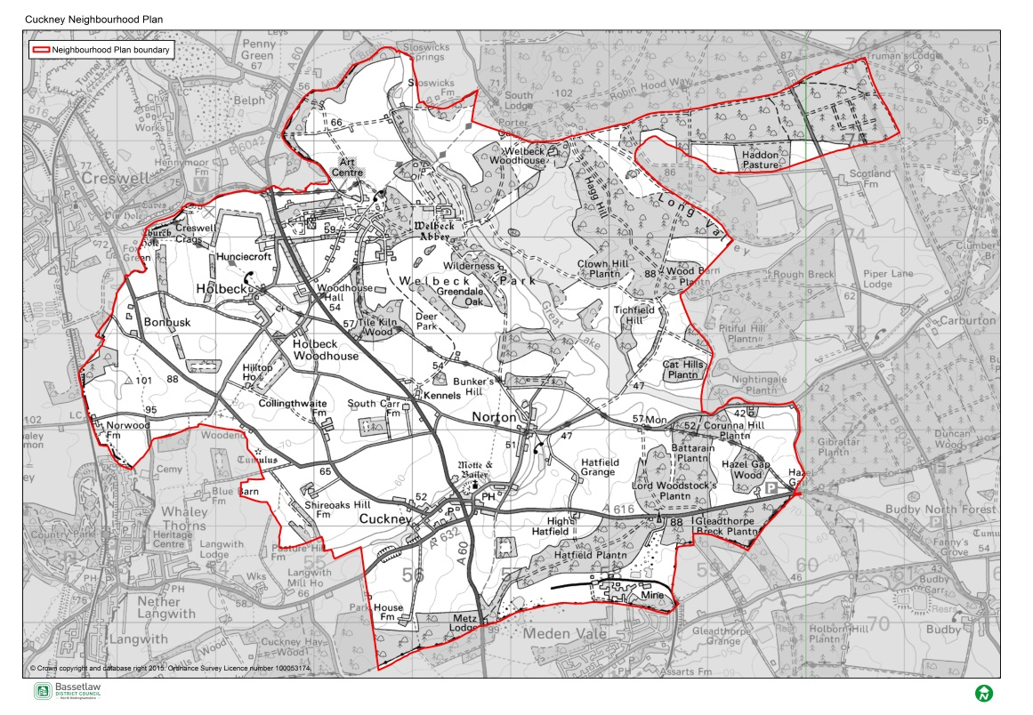
The main priorities of the Cuckney, Norton, Holbeck & Welbeck NP are expressed throughout the Plan, most clearly in its Vision, Aim and Objectives, these will be delivered in turn by the 15 Development Policies and 12 Projects contained in the NP. The Vision, Aim and Objectives of the NP can be found below.
Vision
By 2030 the Neighbourhood Plan area will be thriving, vibrant and community led. It will value its rural environment and heritage and provide the whole community with opportunities to meet their housing, employment and social needs at every stage of their life. It will be a sustainable place where everyone can flourish and prosper.

Objectives
Community Objective 1: To bring forward carefully selected sites to meet the current and future needs of the community (both housing and community facilities) whilst ensuring that such development complements the character of the area.

Community Objective 2: To ensure that all development is designed in accordance with guidelines that reflects the areas distinctive character.

Community Objective 3: To promote development that builds upon the distinctive strengths of the local tourist economy.

Community Objective 4: To support growth and innovation within the local economy that will provide more local job opportunities.

Community Objective 5: To protect, enhance and where possible extend existing open spaces and non-vehicular routes through and out of the Plan area.

Screening Assessment
Criteria for determining the likely significance of effects (Annex II SEA Directive) | Will the NDP have significant environmental effects | Summary of any effects
1a The degree to which the plan or programme sets a framework for projects and other activities, either with regard to the location, nature, size and operating conditions or by allocating resources. | NO | The NP will set out a spatial vision for the designated area of Cuckney, Norton, Holbeck & Welbeck NP area and provides a framework for proposals for development in Cuckney, Norton, Holbeck & Welbeck regarding the following:  - Allocating housing sites  - Design policies  - Sustainable Development  - Community Facilities  - Energy Efficiency  - Tourism  - Designating Local Green Spaces  The NP is considered to be in general conformity with Bassetlaw District Councils Core Strategy 2011. It is also considered to be in general conformity with the National Planning Policy Framework (NPPF).  Several projects are included in the NP that do not directly influence development and land use. These do have regard to the Plan area but it is deemed they will not have any significant effects on the environment.
1b The degree to which the plan or programme influences other plans and programmes including those in a hierarchy. | NO | The NP, where possible, will respond to rather than influence other plans and programmes. An NP can only provide policies within the designated NP area it covers and will also provide policies to help Development Control Officers determine planning applications along with the Bassetlaw District Council Local Plan and the NPPF. None of the policies contained in the NP have a direct impact on other plans in neighbouring areas.  The NP will have some influence on the development proposed in Bassetlaw District Councils Core Strategy (see Policies 1- 18 within the plan). However, as these plans are already significantly developed these likely effects of the NP can be considered as being minimal.
1c The relevance of the plan or programme for the integration of environmental considerations in particular with a view to promoting sustainable development. | NO | The NP sets out and promotes sustainable development within the NP area whilst balancing environmental, social and economic needs within the area. However, local residents have stressed the importance of having some housing development to meet the local housing need in the villages for both, affordable and private housing. This will have an important impact on the community as it will allow for young people to stay in the community and also allow the older generation to down size into smaller properties.  The NP will have a positive impact on the local environment and community assets valued by local people. This will primarily be achieved through Policies: 1, 10, 22, and 23. These Policies have a positive impact on the local environment by protecting and improving assets along with designating areas as local green spaces.  In addition new development is considered to provide important social needs supporting the vitality of the area. The immediate physical impacts of the development on the environment are sought, as far as possible, to be offset.
1d Environmental problems relevant to the plan or programme. | Yes | The majority of effects the NP will have on the environment will be positive. This is due to the numerous Policies in the Plan which aims to protect and enhance environmental assets and the environment in general through good management and the promotion of sustainable development. Some of the projects included in the Plan also have a focus on protecting and enhancing important environmental assets in the Plan area.  The development of the new proposed housing sites will have some environmental concerns relevant to the Plan over the development of Greenfield sites. Because of the proximity of the Site allocations to potentially sensitive areas (e.g. night jar habitat, hedgerows and mature trees) the proposed Site Allocations within the draft plan could potential give rise to significant effects which have not been previously assessed within the sustainability Appraisal on the Bassetlaw District Council Core Strategy. Development on these sites will result in the loss of open space in the countryside.  The noticeable environmental impact brought about by the NP is regarding the increase of road traffic associated with the new houses being built in the area. The increased traffic flow is not however expected to have a significant impact on the environment.  The additional housing is likely to have significant impacts on the local environment. However these developments have been developed in conjunction with Bassetlaw District Council and to some degree have already been explored through consultation with statutory consultees.
1e The relevance of the plan or programme for the implementation of Community legislation on the environment (for example, plans and programmes linked to waste management or water protection). | NO | The NP will be in compliance with the BDC Local Plan which has taken into account existing European and National legislative framework for environmental protection and it will therefore have a positive effect on compliance with regards to relevant legislation and programmes.
2a The probability, duration, frequency and reversibility of the effects. | NO | The timescales of the NP are intended to be the same as that of the Local Plan; therefore the duration of any effects will be up to the year 2028.  Should any unforeseen significant effects on the environment arise as a result of the NP, the intention to monitor and amend/update the Plan every 5 years will allow these effects to be addressed and reversed (see Implementation & Review)
2b The cumulative nature of the effects. | NO | It is considered that the Policies contained in the NP cumulatively will have minimal negative effects on the environment and will in fact have moderate to significant positive effects. It is considered that all effects will be at a local level.
2c The transboundary nature of the effects. | NO | Effects will be local with no expected impacts on neighbouring areas.
2d The risks to human health or the environment (for example, due to accidents). | NO | No obvious risks have been identified as an aim of the NP is to focus on the creation of new and enhancement, protection of existing green spaces and environmental assets as well as the NP area contributing to the enhancement of social wellbeing.
2e The magnitude and spatial extent of the effects (geographical area and size of the population likely to be affected). | NO | The NP area relates to an area of 2884.604 hectares. The resident population of the NP area is approximately 600 (Census 2011).  The whole NP area will be affected by the policies because they are focused upon the whole ward and as such they will have a positive impact upon local residents through the restoration, protection and enhancement of local assets and through the delivery of identified Projects.
2f The value and vulnerability of the area likely to be affected due to:  (i) special natural characteristics or cultural heritage;  (ii) exceeded environmental quality standards or limit values; or  (iii) intensive land-use. | NO | The NP is unlikely to have an adverse effect on the value and vulnerability of the area in relation to its natural and cultural heritage. If anything it will provide greater support to and enhance the setting and identity of the area by supporting the enhancement of its existing environmental and community assets.  The NP provides additional guidance on design principles to ensure that any new developments complement and respect Cuckney, Norton, Holbeck & Welbeck Conservation areas, listed buildings non-designated heritage assets. It is important to local people that any new development is in keeping with the area.  The NP area contains 12 local wildlife sites but there are no plans or proposals that will affect these sites.  The NP does not provide specific policies in relation to intensive land uses.
2g The effects on areas or landscapes which have a recognised national, Community or international protection status. | NO | It is considered that the NP will not adversely affect areas of landscape which have recognised community, national or international protection as the NP aims to enhance, restore and protect important local assets.

As a result of the assessment above, Bassetlaw District Council opinion is that there is a possible significant negative impact on the environment as a result of contents contained in the Cuckney, Norton, Holbeck & Welbeck Neighbourhood Development Plan. The District Council therefore advises that the steering group undertakes a full sustainability appraisal which includes the Strategic Environmental Assessment to assess the impacts.

